**МИНИСТЕРСТВО ЦИФРОВОГО РАЗВИТИЯ СВЯЗИ И МАССОВЫХ КОММУНИКАЦИЙ**

**Ордена Трудового Красного Знамени**

**Федеральное государственное бюджетное образовательное учреждение высшего образования**

**«Московский технический университет связи и информатики»**

Кафедра «Математическая кибернетика и информационные технологии»

**Отчет по лабораторной работе №4**

по дисциплине «Введение в информационные технологии» на тему:

Переводчик Google на Android Studio.

Выполнил: студент группы БВТ2108

Чугунова Татьяна Александровна

Проверил:

Мкртчян Грач Маратович

Москва

2021

1. Цель работы:

Цель работы – создание веб-приложения, которое может переводить фразы на русском языке на английский язык, а фразы на английском языке – на русский.

1. Ход работы

Для начала создадим новый проект в Android Studio и назовем его «LanguageTranslatorApp» (рис.1):

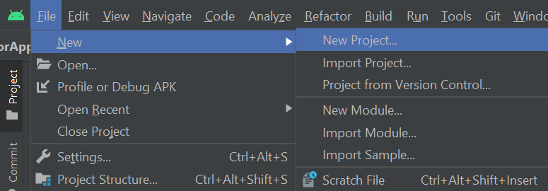

Рисунок Создание проекта

В файл MainActivity.java добавим следующий код:

package com.example.languagetranslatorapp;

import androidx.annotation.NonNull;

import androidx.annotation.Nullable;

import androidx.appcompat.app.AppCompatActivity;

import android.content.Intent;

import android.os.Bundle;

import android.speech.RecognizerIntent;

import android.view.View;

import android.widget.AdapterView;

import android.widget.ArrayAdapter;

import android.widget.ImageView;

import android.widget.Spinner;

import android.widget.TextView;

import android.widget.Toast;

import com.google.android.gms.tasks.OnFailureListener;

import com.google.android.gms.tasks.OnSuccessListener;

import com.google.android.material.button.MaterialButton;

import com.google.android.material.textfield.TextInputEditText;

import com.google.firebase.ml.common.modeldownload.FirebaseModelDownloadConditions;

import com.google.firebase.ml.naturallanguage.FirebaseNaturalLanguage;

import com.google.firebase.ml.naturallanguage.translate.FirebaseTranslateLanguage;

import com.google.firebase.ml.naturallanguage.translate.FirebaseTranslator;

import com.google.firebase.ml.naturallanguage.translate.FirebaseTranslatorOptions;

import java.util.ArrayList;

import java.util.Locale;

public class MainActivity extends AppCompatActivity {

private Spinner fromSpinner, toSpinner;

private TextInputEditText sourceEdt;

private ImageView micTV;

private MaterialButton translateBtn;

private TextView translatedTV;

String[] fromLanguages = {"From", "English", "Africaans", "Arabic", "Belarusian", "Bulgarian", "Bengali",

"Catalan", "Czech", "Welsh", "Urdu", "Russian"};

String[] toLanguages = {"To", "English", "Africaans", "Arabic", "Belarusian", "Bulgarian", "Bengali",

"Catalan", "Czech", "Welsh", "Urdu", "Russian"};

private static final int REQUEST_PERMISSION_CODE = 1;

int languageCode, fromLanguageCode, toLanguageCode = 0;

@Override

protected void onCreate(Bundle savedInstanceState) {

super.onCreate(savedInstanceState);

setContentView(R.layout.activity_main);

fromSpinner = findViewById(R.id.idFromSpinner);

toSpinner = findViewById(R.id.idToSpinner);

sourceEdt = findViewById(R.id.idEdtSource);

micTV = findViewById(R.id.idIVMic);

translateBtn = findViewById(R.id.idBtnTranslate);

translatedTV = findViewById(R.id.idTVTranslatedTV);

fromSpinner.setOnItemSelectedListener(new AdapterView.OnItemSelectedListener(){

@Override

public void onItemSelected(AdapterView<?> parent, View view, int position, long id) {

fromLanguageCode = getLanguageCode(fromLanguages[position]);

}

@Override

public void onNothingSelected(AdapterView<?> parent) {

}

});

ArrayAdapter fromAdapter = new ArrayAdapter(this, R.layout.spinner_item, fromLanguages);

fromAdapter.setDropDownViewResource(android.R.layout.simple_spinner_dropdown_item);

fromSpinner.setAdapter(fromAdapter);

toSpinner.setOnItemSelectedListener(new AdapterView.OnItemSelectedListener() {

@Override

public void onItemSelected(AdapterView<?> parent, View view, int position, long id) {

toLanguageCode = getLanguageCode(toLanguages[position]);

}

@Override

public void onNothingSelected(AdapterView<?> parent) {

}

});

ArrayAdapter toAdapter = new ArrayAdapter(this, R.layout.spinner_item, toLanguages);

toAdapter.setDropDownViewResource(android.R.layout.simple_spinner_dropdown_item);

toSpinner.setAdapter(toAdapter);

translateBtn.setOnClickListener(new View.OnClickListener() {

@Override

public void onClick(View v) {

translatedTV.setText("");

if(sourceEdt.getText().toString().isEmpty()){

Toast.makeText(MainActivity.this, "Please enter your text to translate", Toast.LENGTH_SHORT).show();

}else if(fromLanguageCode==0){

Toast.makeText(MainActivity.this, "Please select source language", Toast.LENGTH_SHORT).show();

}else if(toLanguageCode==0){

Toast.makeText(MainActivity.this, "Please select the language to make translation", Toast.LENGTH_SHORT).show();

}else{

translateText(fromLanguageCode, toLanguageCode, sourceEdt.getText().toString());

}

}

});

micTV.setOnClickListener(new View.OnClickListener() {

@Override

public void onClick(View v) {

Intent i = new Intent(RecognizerIntent.ACTION_RECOGNIZE_SPEECH);

i.putExtra(RecognizerIntent.EXTRA_LANGUAGE_MODEL, RecognizerIntent.LANGUAGE_MODEL_FREE_FORM);

i.putExtra(RecognizerIntent.EXTRA_LANGUAGE, Locale.getDefault());

i.putExtra(RecognizerIntent.EXTRA_PROMPT, "Speak to convert into text");

try {

startActivityForResult(i, REQUEST_PERMISSION_CODE);

}catch (Exception e){

e.printStackTrace();

Toast.makeText(MainActivity.this, ""+e.getMessage(), Toast.LENGTH_SHORT).show();

}

}

});

}

@Override

protected void onActivityResult(int requestCode, int resultCode, @Nullable Intent data) {

super.onActivityResult(requestCode, resultCode, data);

if(requestCode==REQUEST_PERMISSION_CODE){

if(resultCode==RESULT_OK && data!=null){

ArrayList<String> result = data.getStringArrayListExtra(RecognizerIntent.EXTRA_RESULTS);

sourceEdt.setText(result.get(0));

}

}

}

private void translateText(int fromLanguageCode, int toLanguageCode, String source){

translatedTV.setText("Downloadind Modal...");

FirebaseTranslatorOptions options = new FirebaseTranslatorOptions.Builder()

.setSourceLanguage(fromLanguageCode)

.setTargetLanguage(toLanguageCode)

.build();

FirebaseTranslator translator = FirebaseNaturalLanguage.getInstance().getTranslator(options);

FirebaseModelDownloadConditions conditions = new FirebaseModelDownloadConditions.Builder().build();

translator.downloadModelIfNeeded(conditions).addOnSuccessListener(new OnSuccessListener<Void>() {

@Override

public void onSuccess(Void unused) {

translatedTV.setText("Translating...");

translator.translate(source).addOnSuccessListener(new OnSuccessListener<String>() {

@Override

public void onSuccess(String s) {

translatedTV.setText(s);

}

}).addOnFailureListener(new OnFailureListener() {

@Override

public void onFailure(@NonNull Exception e) {

Toast.makeText(MainActivity.this, "Fail to translate: "+e.getMessage(), Toast.LENGTH_SHORT).show();

}

});

}

}).addOnFailureListener(new OnFailureListener() {

@Override

public void onFailure(@NonNull Exception e) {

Toast.makeText(MainActivity.this, "Fail to download language Modal "+e.getMessage(), Toast.LENGTH_SHORT).show();

}

});

}

//String[] toLanguages = {"To", "English", "Africaans", "Arabic", "Belarusian", "Bulgarian", "Bengali",

// "Catalan", "Czech", "Welsh", "Urdu", "Russian"};

public int getLanguageCode(String language) {

int languageCode = 0;

switch (language){

case "English":

languageCode = FirebaseTranslateLanguage.EN;

break;

case "Africaans":

languageCode = FirebaseTranslateLanguage.AF;

break;

case "Arabic":

languageCode = FirebaseTranslateLanguage.AR;

break;

case "Belarusian":

languageCode = FirebaseTranslateLanguage.BE;

break;

case "Bengali":

languageCode = FirebaseTranslateLanguage.BN;

break;

case "Catalan":

languageCode = FirebaseTranslateLanguage.CA;

break;

case "Czech":

languageCode = FirebaseTranslateLanguage.CS;

break;

case "Welsh":

languageCode = FirebaseTranslateLanguage.CS;

break;

case "Urdu":

languageCode = FirebaseTranslateLanguage.UR;

break;

case "Russian":

languageCode = FirebaseTranslateLanguage.RU;

break;

default:

languageCode = 0;

}

return languageCode;

}

}

В файл activity_main.xml добавим следующее:

<?xml version="1.0" encoding="utf-8"?>

<LinearLayout xmlns:android="http://schemas.android.com/apk/res/android"

xmlns:app="http://schemas.android.com/apk/res-auto"

xmlns:tools="http://schemas.android.com/tools"

android:layout_width="match_parent"

android:orientation="vertical"

android:background="@color/black_shade_1"

android:layout_height="match_parent"

style="@style/AppTheme.MaterialTheme"

tools:context=".MainActivity">

<TextView

android:layout_width="match_parent"

android:layout_height="wrap_content"

android:text="Language Translator"

android:textAlignment="center"

android:layout_marginTop="20dp"

android:textSize="20sp"

android:textColor="@color/yellow"

android:gravity="center"

android:textStyle="bold"

android:padding="4dp"

/>

<LinearLayout

android:layout_width="match_parent"

android:layout_height="wrap_content"

android:orientation="horizontal"

android:weightSum="3"

android:layout_marginStart="20dp"

android:layout_marginEnd="20dp"

android:layout_marginTop="20dp"

>

<Spinner

android:layout_width="0dp"

android:layout_height="wrap_content"

android:layout_weight="1"

android:id="@+id/idFromSpinner"

android:layout_margin="3dp"

android:gravity="center" />

<ImageView

android:layout_width="0dp"

android:layout_height="wrap_content"

android:layout_weight="1"

android:src="@drawable/ic_right_arrow"

app:tint="@color/white"

android:layout_gravity="center"

/>

<Spinner

android:layout_width="0dp"

android:layout_height="wrap_content"

android:layout_weight="1"

android:id="@+id/idToSpinner"

android:padding="3dp"

android:gravity="center"

android:layout_margin="3dp" />

</LinearLayout>

<com.google.android.material.textfield.TextInputLayout

android:layout_width="match_parent"

android:layout_height="100dp"

android:layout_marginStart="20dp"

android:layout_marginEnd="20dp"

android:layout_marginTop="20dp"

style="@style/Widget.MaterialComponents.TextInputLayout.OutlinedBox"

android:hint="Source Text"

android:padding="5dp"

android:textColorHint="@color/white"

app:hintTextColor="@color/white"

>

<com.google.android.material.textfield.TextInputEditText

android:layout_width="match_parent"

android:layout_height="match_parent"

android:id="@+id/idEdtSource"

android:ems="10"

android:importantForAutofill="no"

android:inputType="textImeMultiLine|textMultiLine"

android:textColor="@color/white"

android:textColorHint="@color/white"

android:textSize="14sp"/>

</com.google.android.material.textfield.TextInputLayout>

<TextView

android:layout_width="match_parent"

android:layout_height="wrap_content"

android:text="OR"

android:textAllCaps="true"

android:textColor="@color/white"

android:textSize="20sp"

android:textAlignment="center"

android:layout_gravity="center"

android:layout_marginTop="5dp"

/>

<ImageView

android:layout_width="70dp"

android:layout_height="70dp"

android:layout_gravity="center"

android:layout_marginTop="10dp"

android:src="@drawable/ic_mic"

android:tint="@color/yellow"

android:id="@+id/idIVMic"

/>

<TextView

android:layout_width="wrap_content"

android:layout_height="wrap_content"

android:text="Say Something"

android:textAlignment="center"

android:textColor="@color/white"

android:textSize="15sp"

android:layout_gravity="center"/>

<com.google.android.material.button.MaterialButton

android:id="@+id/idBtnTranslate"

android:layout_width="match_parent"

android:layout_height="wrap_content"

android:layout_marginStart="20dp"

android:layout_marginEnd="20dp"

android:layout_marginTop="20dp"

android:text="Translate"

android:textAllCaps="false"

/>

<TextView

android:id="@+id/idTVTranslatedTV"

android:layout_width="match_parent"

android:layout_height="wrap_content"

android:layout_gravity="center"

android:layout_marginTop="30dp"

android:text="Translated text"

android:textAlignment="center"

android:textAllCaps="false"

android:textColor="@color/yellow"

android:textSize="18sp" />

</LinearLayout>

В файл spinner_item.xml добавим следующее:

<?xml version="1.0" encoding="utf-8"?>

<TextView xmlns:android="http://schemas.android.com/apk/res/android"

android:layout_width="match_parent"

android:layout_height="wrap_content"

android:gravity="center"

android:padding="4dp"

android:textAlignment="center"

android:textColor="@color/white" >

</TextView>

В файл ic_mic.xml и ic_right_arrow.xml добавим следующее:

<vector xmlns:android="http://schemas.android.com/apk/res/android"

android:width="24dp"

android:height="24dp"

android:viewportWidth="24"

android:viewportHeight="24"

android:tint="?attr/colorControlNormal">

<path

android:fillColor="@android:color/white"

android:pathData="M12,14c1.66,0 2.99,-1.34 2.99,-3L15,5c0,-1.66 -1.34,-3 -3,-3S9,3.34 9,5v6c0,1.66 1.34,3 3,3zM17.3,11c0,3 -2.54,5.1 -5.3,5.1S6.7,14 6.7,11L5,11c0,3.41 2.72,6.23 6,6.72L11,21h2v-3.28c3.28,-0.48 6,-3.3 6,-6.72h-1.7z"/>

</vector>

В файл build.gradle добавим следующее:

plugins {

id 'com.android.application'

id 'com.google.gms.google-services'

}

android {

compileSdk 31

defaultConfig {

applicationId "com.example.languagetranslatorapp"

minSdk 16

targetSdk 31

versionCode 1

versionName "1.0"

testInstrumentationRunner "androidx.test.runner.AndroidJUnitRunner"

}

buildTypes {

release {

minifyEnabled false

proguardFiles getDefaultProguardFile('proguard-android-optimize.txt'), 'proguard-rules.pro'

}

}

compileOptions {

sourceCompatibility JavaVersion.VERSION_1_8

targetCompatibility JavaVersion.VERSION_1_8

}

}

dependencies {

implementation 'androidx.appcompat:appcompat:1.4.0'

implementation 'com.google.android.material:material:1.4.0'

implementation 'androidx.constraintlayout:constraintlayout:2.1.2'

implementation 'com.google.firebase:firebase-core:17.3.0'

implementation 'com.google.firebase:firebase-ml-natural-language:22.0.0'

implementation 'com.google.firebase:firebase-ml-natural-language-translate-model:20.0.8'

testImplementation 'junit:junit:4.+'

androidTestImplementation 'androidx.test.ext:junit:1.1.3'

androidTestImplementation 'androidx.test.espresso:espresso-core:3.4.0'

}

1. Результат

Вот так выглядит наше приложение (рис.2):

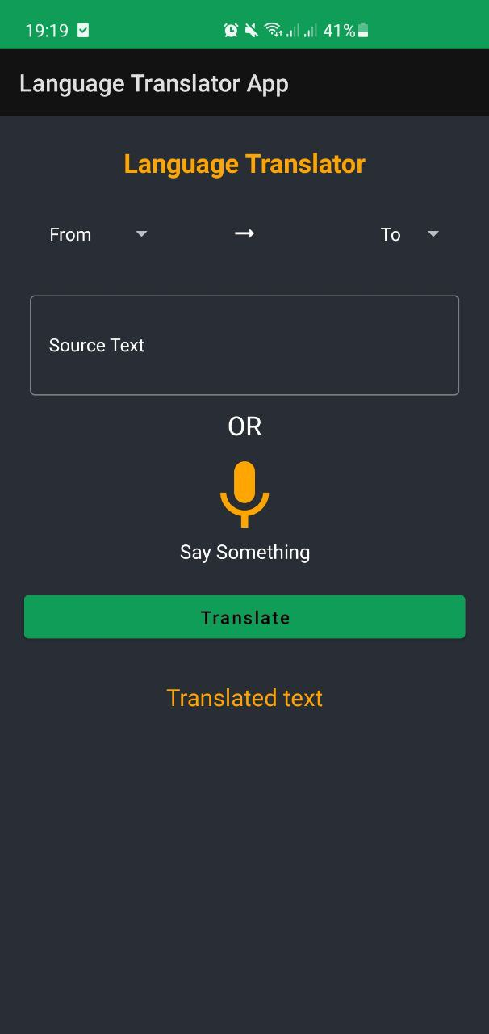

Рисунок Вид приложения

Попробуем перевести русское слово на английский (рис.3):

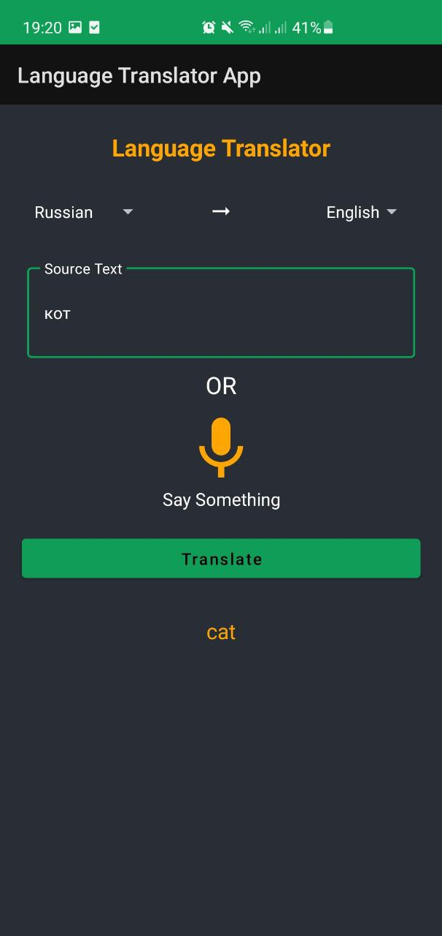

Рисунок Перевод

И наоборот (рис.4):

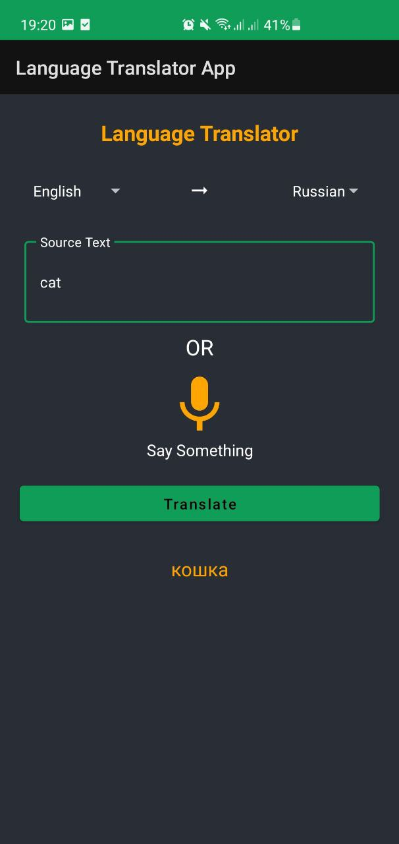

Рисунок Перевод

1. Вывод

Мы научились пользоваться Android Studio и ML Firebase, создав на их основе android-приложение, которое переводит русские слова на английский.